**PRAGNYA DESHPANDE**

**2GI20CS088**

**TERMWORK 2.2**

2.2) Define a class to represent the student details such as name, roll number, marks obtained in three internal assessment tests.

1. Identify type and declare the instance variables
2. Identify and develop the constructors to initialize the instance variables
3. Write a method computeAverage() to compute the average as the average of best two marks
4. Write a method to display the student details

Write the corresponding Driver class to instantiate an array of student objects and demonstrate the working of the application by invoking appropriate methods.

**CODE:**

**import java.util.*;**

**class Student**

**{**

**String name;**

**int rollno;**

**float m1,m2,m3;**

**Student()**

**{**

**Scanner in=new Scanner(System.in);**

**System.out.println("Enter name:");**

**name=in.nextLine();**

**System.out.println("Enter rollno:");**

**rollno=in.nextInt();**

**System.out.println("Enter marks:");**

**m1=in.nextFloat();**

**m2=in.nextFloat();**

**m3=in.nextFloat();**

**}**

**Student(String n,int r,float mr1,float mr2,float mr3)**

**{**

**name=n;**

**rollno=r;**

**m1=mr1;**

**m2=mr2;**

**m3=mr3;**

**}**

**float computAverage()**

**{**

**if(m1>m2 && m2>m3)**

**return (m1+m2)/2;**

**else if(m2>m3 && m3>m1)**

**return (m2+m3)/2;**

**else**

**return (m1+m3)/2;**

**}**

**void disp()**

**{**

**System.out.println("Name:\n"+name+"\nRoll no:"+rollno);**

**System.out.println("Marks:\n"+m1+"\n"+m2+"\n"+m3);**

**}**

**}**

**public class Termwork22**

**{**

**public static void main(String args[])**

**{**

**Student s1=new Student();**

**s1.disp();**

**System.out.println("Average marks:"+s1.computAverage());**

**System.out.println("\n");**

**Student s2=new Student("Harry",28,30,28,29);**

**s2.disp();**

**System.out.println("Average marks:"+s2.computAverage());**

**}**

**}**

**OUTPUT:**

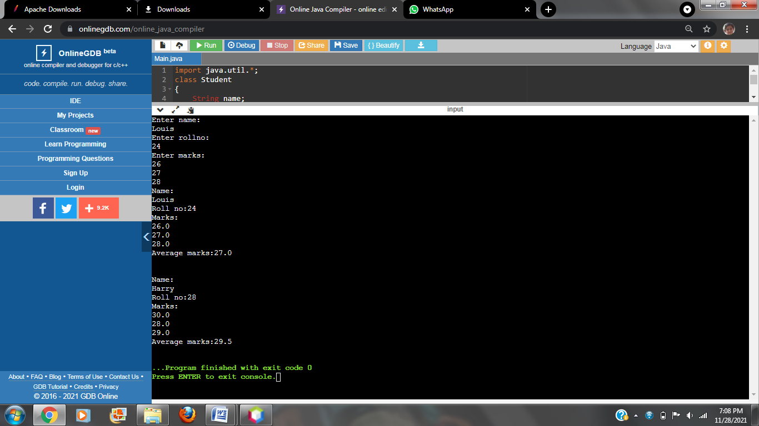

**PRAGNYA DESHPANDE**

**2GI20CS088**

**TERMWORK 3.2**

3.2) Define a class to represent a rectangle in which constructors and parameterized methods are used. It also has a method to compute area of rectangle.

1. First make a class rectangle in which we declare the parameterized constructor.
2. Then demonstrate the use of parameterized method.
3. Use a method to compute area of rectangle.
4. Create a class to demonstrate the call of the methods in previously created class rectangle holding constructors, parameterized methods and method to compute area of rectangle.

**CODE:**

**import java.util.*;**

**class Rectangle**

**{**

**float l,b;**

**Rectangle()**

**{**

**l=0;**

**b=0;**

**}**

**Rectangle(float l1,float b1)**

**{**

**l=l1;**

**b=b1;**

**}**

**void read(float l2,float b2)**

**{**

**l=l2;**

**b=b2;**

**}**

**float area()**

**{**

**return l*b;**

**}**

**void disp()**

**{**

**System.out.println("Length="+l+"\nBreadth="+b);**

**System.out.println("Area of rectangle="+area());**

**}**

**}**

**public class Main**

**{**

**public static void main (String[] args)**

**{**

**Rectangle r1=new Rectangle(12,11);**

**r1.disp();**

**Rectangle r2=new Rectangle();**

**r2.read(10,15);**

**r2.disp();**

**}**

**}**

**OUTPUT:**

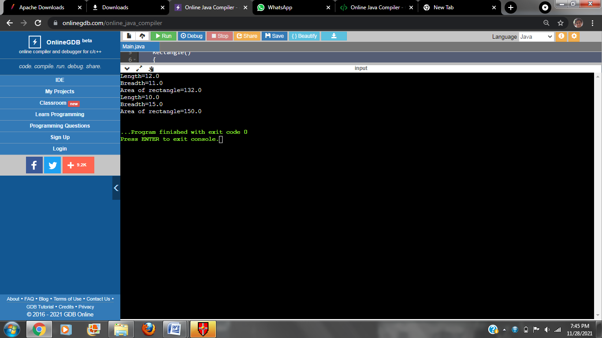

**PRAGNYA DESHPANDE**

**2GI20CS088**

**TERMWORK 2.1**

2.1) Design a class by name myCircle to model Circle geometrical object with its center and radius that enables:

1. Initializing the center, radius and
2. Compute area, perimeter, and diameter of the circle object/s.

TASK 1: Identify member variable/s and their types

TASK 2: Identify Constructor/s along with their arguments (if any) to initialize the member variables

TASK 3: Identify the methods along with their arguments and return types.

TASK 4: Identify member variable getters/setters (if needed)

**CODE:**

**import java.util.*;**

**class myCircle**

**{**

**float x,y,rad;**

**myCircle()**

**{**

**Scanner in=new Scanner(System.in);**

**System.out.println("Enter radius:");**

**rad=in.nextFloat();**

**x=0;**

**y=0;**

**}**

**float diameter()**

**{**

**return 2*rad;**

**}**

**float perimeter()**

**{**

**return 3.142f*(diameter());**

**}**

**float area()**

**{**

**return 3.142f*rad*rad;**

**}**

**}**

**class termwork21**

**{**

**public static void main (String[] args)**

**{**

**myCircle c1=new myCircle();**

**System.out.println("Diameter="+c1.diameter());**

**System.out.println("Perimeter="+c1.perimeter());**

**System.out.println("Area="+c1.area());**

**}**

**}**

**OUTPUT:**

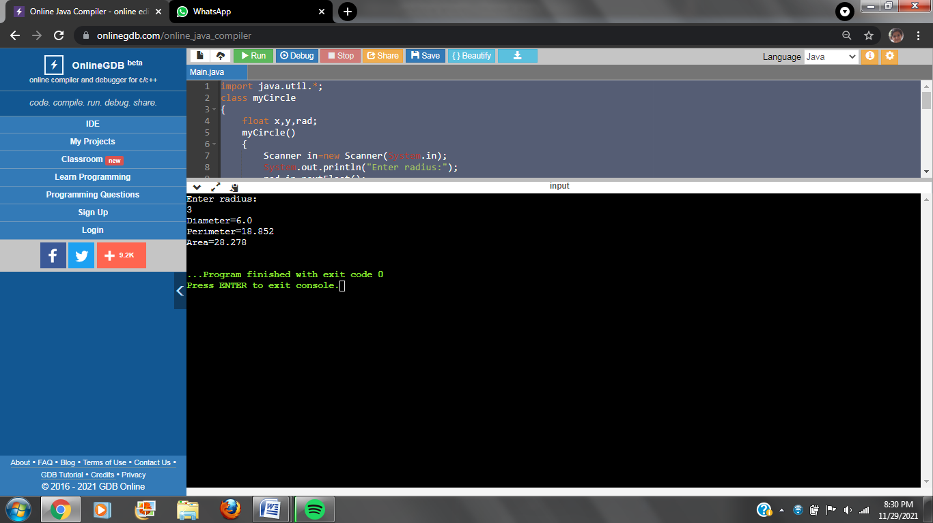

**PRAGNYA DESHPANDE**

**2GI20CS088**

**TERMWORK 3.3**

3.3) Write a Java program to represent a Complex number. Include member functions to:

1. Initialize a complex number to a default value of zero (default constructor)
2. Initialize a complex number to a user defined value (parameterized constructor)
3. Add two complex numbers and return the result. (Parameterized method)
4. Subtract two complex numbers and return the result. (Parameterized method)
5. Display a complex number. (non-parameterized method)

**CODE:**

**import java.util.*;**

**class Complex**

**{**

**int real,img;**

**Complex()**

**{**

**real=0;**

**img=0;**

**}**

**Complex(int r, int i)**

**{**

**real=r;**

**img=i;**

**}**

**Complex add(Complex c1, Complex c2)**

**{**

**Complex c=new Complex();**

**c.real=c1.real+c2.real;**

**c.img=c1.img+c2.img;**

**return c;**

**}**

**Complex sub(Complex c1, Complex c2)**

**{**

**Complex c=new Complex();**

**c.real=c1.real-c2.real;**

**c.img=c1.img-c2.img;**

**return c;**

**}**

**void disp()**

**{**

**if(img>0)**

**System.out.println(""+real+"+i"+img);**

**else**

**System.out.println(""+real+"-i"+(-img));**

**}**

**}**

**class termwork33**

**{**

**public static void main(String args[])**

**{**

**Complex c1=new Complex(3,5);**

**Complex c2=new Complex(4,6);**

**Complex c3=new Complex();**

**System.out.println("C1:");**

**c1.disp();**

**System.out.println("C2:");**

**c2.disp();**

**c3=c3.add(c1,c2);**

**System.out.println("Addition of c1 and c2:");**

**c3.disp();**

**c3=c3.sub(c1,c2);**

**System.out.println("Difference of c1 and c2:");**

**c3.disp();**

**}**

**}**

**OUTPUT:**

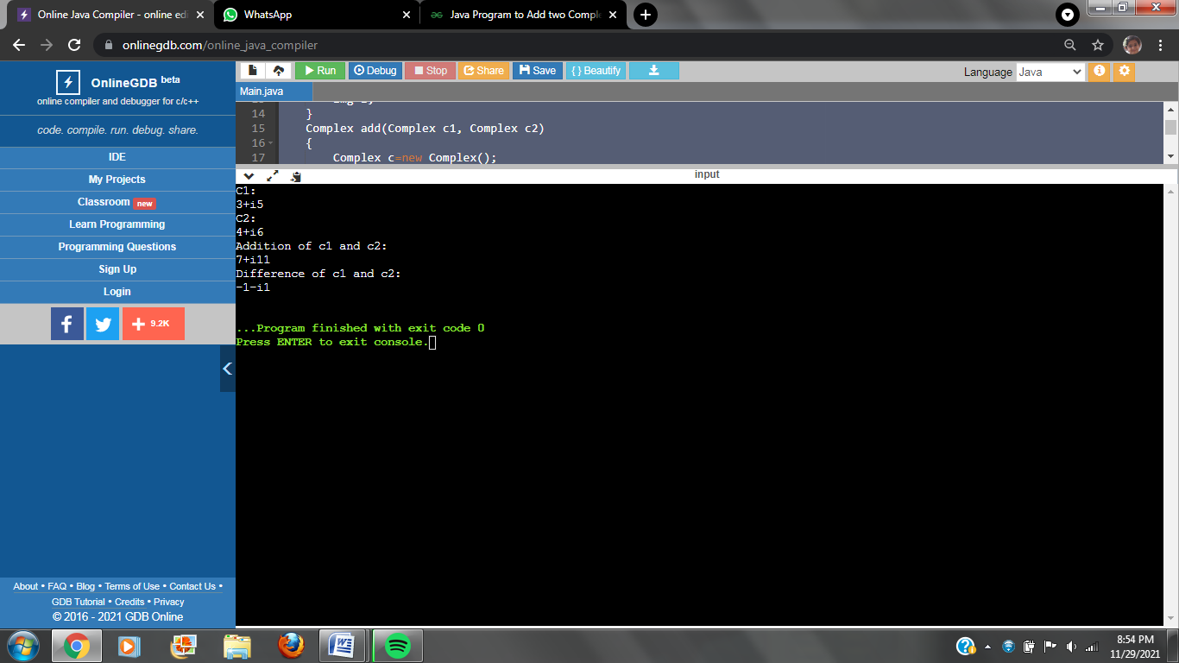

**PRAGNYA DESHPANDE  
2GI20CS088**

**TERMWORK 1.2**

1.2) A joint family consisting of 10 households lives in the same compound. Due to mounting electricity bills, the head (Mr. X) of the joint family decides to analyze the consumption pattern (in terms of the billed amount) of each household for a year. Mr. X needs access to the following information for his analysis:

1. The total expenditure on electricity consumption by each household in a year.
2. The maximum and minimum electricity consumption of each household in a year.
3. The amount by which each household exceeded the average consumption (+/-) of all households in the month of June.
4. The maximum, minimum and average electricity consumption of all households in a year.

Demonstrate how you would use a two dimensional matrix to help Mr. X.

**CODE:**

**import java.util.Scanner;**

**class office**

**{**

**static int maximum(int a[])**

**{**

**int m=0,pos=0;**

**for(int i=0;i<10;i++)**

**{**

**if(a[i]>m)**

**{**

**m=a[i];**

**pos=i+1;**

**}**

**}**

**return pos;**

**}**

**static int minimum(int a[])**

**{**

**int m=99999,pos=0;**

**for(int i=0;i<10;i++)**

**{**

**if(a[i]<m)**

**{**

**m=a[i];**

**pos=i+1;**

**}**

**}**

**return pos;**

**}**

**public static void main(String[]args)**

**{**

**Scanner venki = new Scanner(System.in);**

**int data[][]=new int[4][10];**

**int i,j,max[]=new int[4];**

**int min[]=new int[4];**

**float avg[]=new float[4];**

**String zones[]={"North","South","East","West"};**

**System.out.println("Enter the data of the zones : ");**

**for(i=0;i<4;i++)**

**{**

**System.out.println("\n"+zones[i]+" : ");**

**int sum=0;**

**for(j=0;j<10;j++)**

**{**

**System.out.println("Office "+(j+1)+" : ");**

**data[i][j]=venki.nextInt();**

**sum+=data[i][j];**

**}**

**avg[i]=sum/10;**

**max[i] = maximum(data[i]);**

**min[i] = minimum(data[i]);**

**}**

**System.out.println("\nOffice Number with highest sales zone wise : ");**

**for(i=0;i<4;i++)**

**System.out.println(zones[i]+" : "+max[i]);**

**System.out.println("\nOffice with poorest sales zone wise : ");**

**for(i=0;i<4;i++)**

**System.out.println(zones[i]+" : "+min[i]);**

**System.out.println("\nAverage sales zone wise : ");**

**for(i=0;i<4;i++)**

**System.out.println(zones[i]+" : "+avg[i]);**

**}**

**}**

**OUTPUT:**

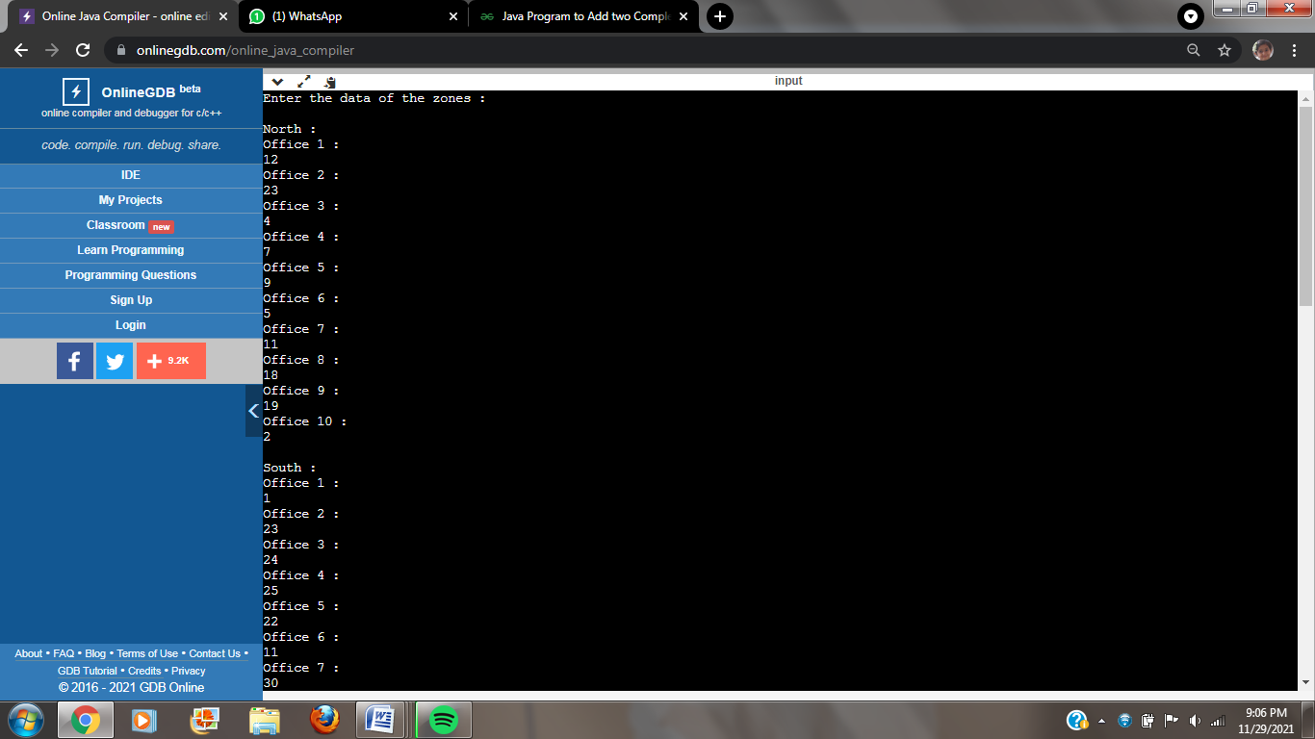

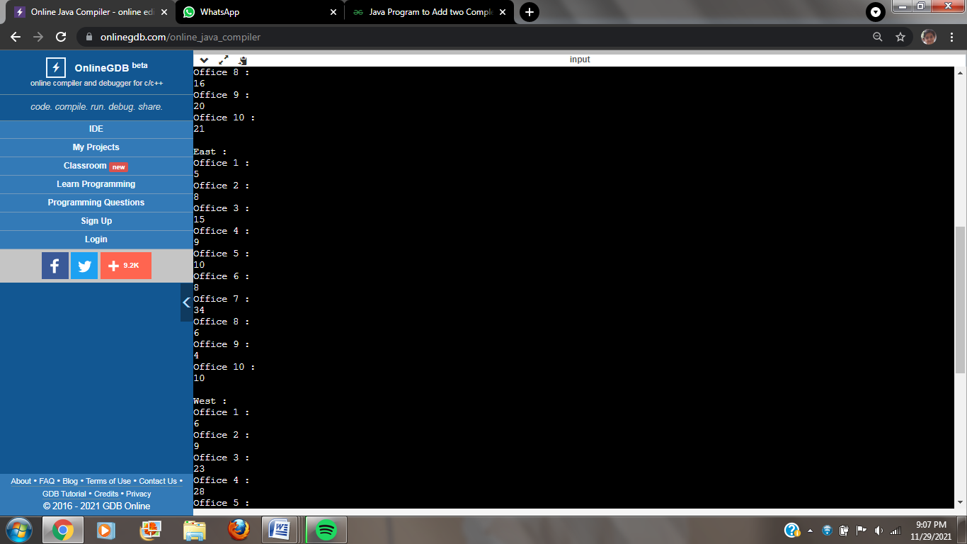

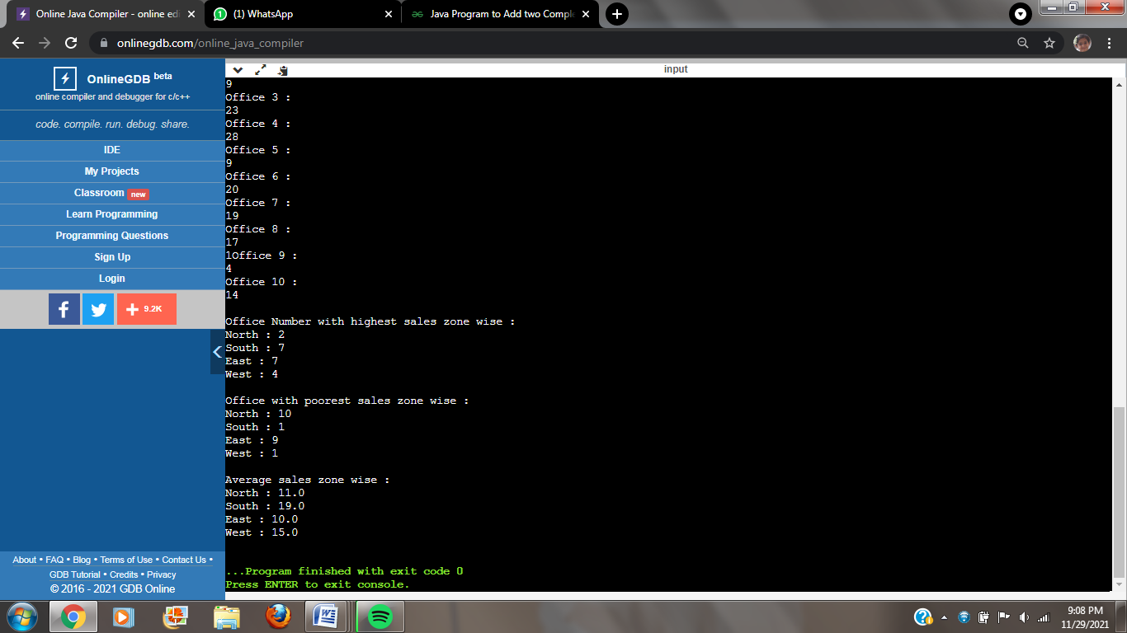

**PRAGNYA DESHPANDE**

**2GI20CS088**

**TERMWORK 1.1**

1.1) It is required to store and analyze data about 6 car manufacturer’s sales data in all the 12 months of a year. Demonstrate how you would store the data in a two dimensional matrix and do the following

1. Write a function to Find for a given car manufacturer, the month in which, maximum no. of cars are sold.
2. Write a function to Find the average number of cars sold for each car manufacturer
3. Write a function to Find the total number of cars sold for each car manufacturer.
4. Write a function to find standard deviation for a given car manufacturer

Assume – row index 0 - ‘Maruti Suzuki’, 1 – ‘Hundai’ 2 – ‘Tata Motors’ 3-‘KIA’ 4 – ‘BMW’ 5 – ‘Renault’

Col index 0 –‘Jan’, 1-‘Feb’………………………………….11 –‘Dec’

Demonstrate the working of the program with appropriate values for each car manufacturer and the months.

**CODE:**

**import java.util.Scanner;**

**class car {**

**public static void main(String[] args)**

**{**

**Scanner in=new Scanner(System.in);**

**int carSale[][]=new int[6][12];**

**int n;**

**for(int i=0;i<6;i++)**

**{**

**System.out.println("Enter the Sale per month for manufacturer "+(i+1)+":");**

**for(int j=0;j<12;j++)**

**{**

**carSale[i][j]=in.nextInt();**

**}**

**}**

**System.out.println("Enter the manufacturer no. to find the maximum car sold:");**

**n=in.nextInt();**

**max(carSale,n); //calling max method**

**System.out.println("\nThe average cars sold by");**

**average(carSale);**

**System.out.println("\nThe total carssold by ");**

**total(carSale);**

**}**

**static void max(int[][] carSale,int n)**

**{**

**int count=carSale[n-1][0],month=1;**

**for(int j=0;j<12;j++)**

**{**

**if(carSale[n-1][j]>count)**

**{**

**count=carSale[n-1][j];**

**month=j+1;**

**}**

**}**

**switch(month)**

**{**

**case 1:System.out.println("\nThe maximum number of cars sold by manufacturer "+n+" is in January.");**

**break;**

**case 2:System.out.println("\nThe maximum number of cars sold by manufacturer "+n+" is in February.");**

**break;**

**case 3:System.out.println("\nThe maximum number of cars sold by manufacturer "+n+" is in March.");**

**break;**

**case 4:System.out.println("\nThe maximum number of cars sold by manufacturer "+n+" is in April.");**

**break;**

**case 5:System.out.println("\nThe maximum number of cars sold by manufacturer "+n+" is in May.");**

**break;**

**case 6:System.out.println("\nThe maximum number of cars sold by manufacturer "+n+" is in June.");**

**break;**

**case 7:System.out.println("\nThe maximum number of cars sold by manufacturer "+n+" is in July.");**

**break;**

**case 8:System.out.println("\nThe maximum number of cars sold by manufacturer "+n+" is in August.");**

**break;**

**case 9:System.out.println("\nThe maximum number of cars sold by manufacturer "+n+" is in September.");**

**break;**

**case 10:System.out.println("\nThe maximum number of cars sold by manufacturer "+n+" is in October.");**

**break;**

**case 11:System.out.println("\nThe maximum number of cars sold by manufacturer "+n+" is in November.");**

**break;**

**case 12:System.out.println("\nThe maximum number of cars sold by manufacturer "+n+" is in December.");**

**break;**

**}**

**}**

**static void average(int[][] carSale)**

**{**

**float avg;**

**int sum=0;**

**for(int i=0;i<6;i++)**

**{**

**for(int j=0;j<12;j++)**

**{**

**sum+=carSale[i][j];**

**}**

**avg=sum/12f;**

**System.out.println("Manufacturer "+(i+1)+" :"+avg);**

**sum=0;**

**}**

**}**

**static void total(int[][] carSale)**

**{**

**int sum=0;**

**for(int i=0;i<6;i++)**

**{**

**for(int j=0;j<12;j++)**

**{**

**sum+=carSale[i][j];**

**}**

**System.out.println("Manufacturer "+(i+1)+" :"+sum);**

**sum=0;**

**}**

**}**

**}**

**OUTPUT:**

